RESOLUTION NO.__________

RE: CERTIFICATE OF APPROPRIATENESS UNDER THE
PROVISIONS OF THE ACT OF THE PENNSYLVANIA
LEGISLATURE 1961, JUNE 13, P.L. 282 (53
SECTION 8004) AND BETHLEHEM ORDINANCE NO.
3952 AS AMENDED.

The applicant proposes to re-cover the existing awning at 77 W. Broad St.

NOW, THEREFORE, BE IT RESOLVED by the Council of the City of Bethlehem that a Certificate of Appropriateness is hereby granted for the proposal.

Sponsored by: (s)

(s)

ADOPTED BY COUNCIL THIS DAY OF

(s)
President of Council

ATTEST:

(s)
City Clerk

HISTORICAL & ARCHITECTURAL REVIEW BOARD

The applicant proposes to re-cover the existing awning at
77 W. Broad St.

APPLICATION #3:

Faustina & Andrew Talego
77 W. Broad St.
Bethlehem, PA 18018

OWNER:

__________________________________________________________________________

The Board upon motion by Beth Starbuck and seconded by Diana Hodgson adopted the proposal that City Council issue a Certificate of Appropriateness for the following:

- To re-cover the existing awning with a new awning.

2. Lettering to be white/silver/off-white.

3. Awning at the end can be open.

4. Addition to hours to the door in block lettering same color.

5. The motion was unanimously approved.

__________________________________________________________________________

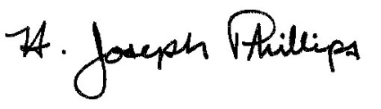
By:__H. Joseph Phillips___________

Title: __Historic Officer____________

Date of Meeting: September 5, 2018

